Faithful Living…..Fearless Leading
Joshua 3:1-17
Crossing the River Jordan

Observations from Joshua 3:1-17
Repeated words:

Key Words or phrases:

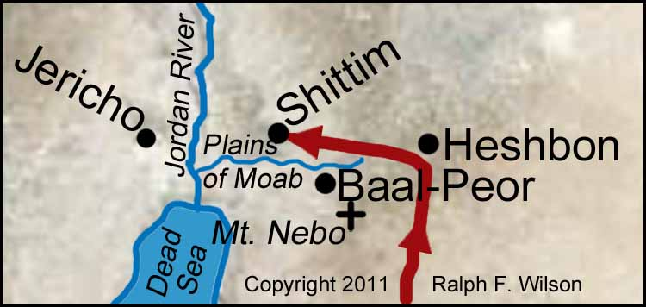

What does “consecrate” mean? (verse 5)

What elements were in the Ark of the Covenant?

-
-
-

Four Actions instructed by God for the people
_____________________vs.2-4

_____________________vs.5

_____________________vs.7-11

_____________________vs.8

Jordan River - Leadership Lessons

Lesson # 1

Lesson # 2

Lesson # 3

Lesson #4



www.equipministriesinternational.org

